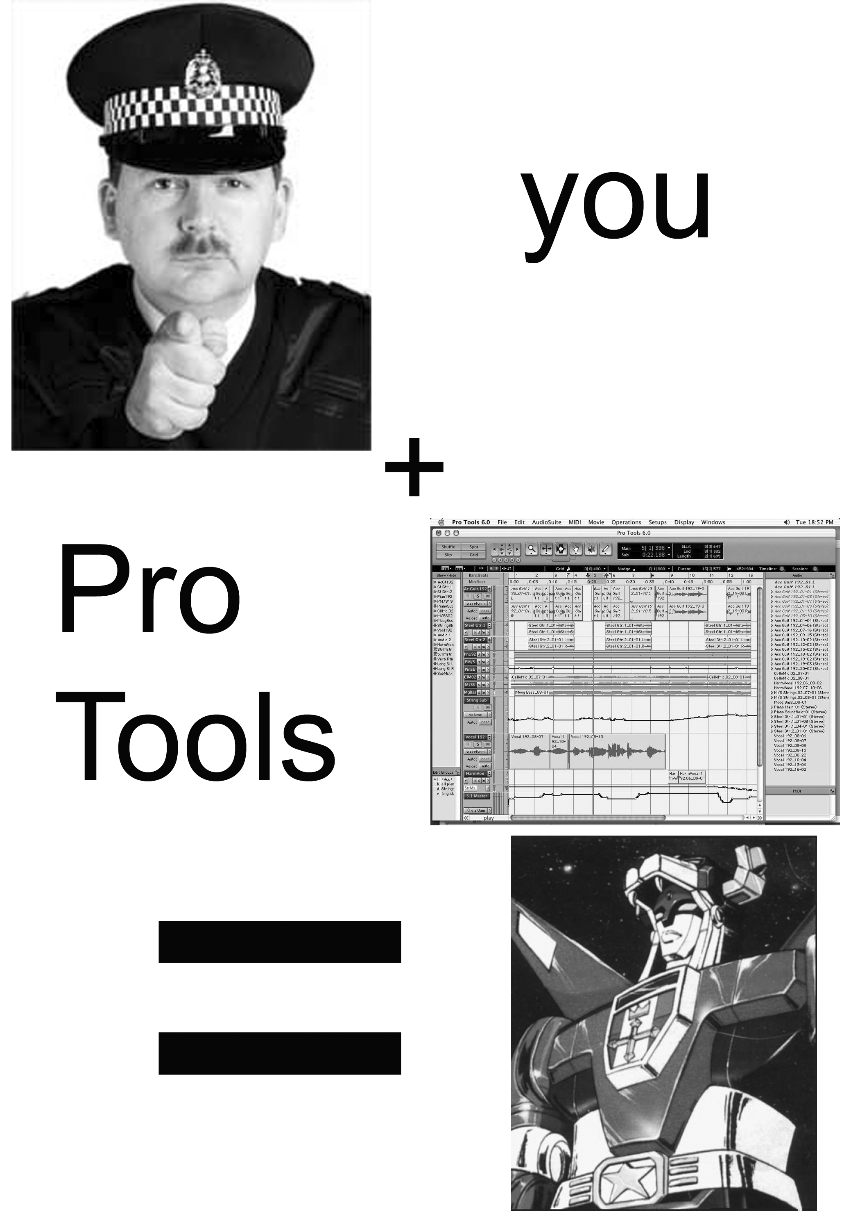

This packet was designed to be a relatively “quick & easy” intro to Pro Tools. Unfortunately, it has quickly spiraled into many, many pages.

We will start by talking a little bit about digital audio in general.

We will then go over the Pro Tools interface to try to get a feel for the “philosophy” of its design.

Then we’ll look through two projects (one strictly musical, the other more of an audio documentary) and go through editing, effects, automation, and mixing.

By the way, I have stolen liberally from other tutorials. I doubt you’ll mind, but it should be known.

- Digital Audio

We will begin by trying to give a basic overview of digital audio. This is pretty dry material, and there’s no real way to “sex-it-up”. Bear with me, and I can promise that half of the problems you face this semester can be solved.

You may have heard that digital audio simply tries to emulate analog audio, so let’s define analog audio first.

For the last 120 years, audio has been captured and reproduced by using a microphone to measure variations in sound pressure. Microphones do this in a variety of ways. The simplest example is a Dynamic Microphone (a la a Shure SM57 or SM58). The dynamic microphone contains a diaphragm that vibrates with sound pressure. These vibrations register as variations in voltage. This voltage variation is amplified then passed on to a recording medium (wax cylander, magnetic tape). When the recorded medium is played back, these voltage variations are amplified and sent to another vibrating diaphragm, in this case, a speaker. The diaphragm vibrates and produces audible compression waves.

A picture should help:

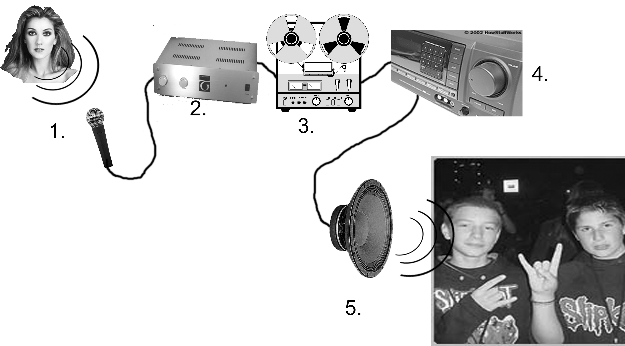
- Compression waves make a diaphragm vibrate. The vibrations cause voltage fluctuations.
- These fluctuations are amplified. (note: amplifiers before recording are called pre-amplifiers or pre-amps to avoid confusion.)
- The amplified voltage fluctuations are recorded to a medium (magnetic tape).
- The recorded fluctuations are played back off of the medium.
- The fluctuations are sent to an amplifier
- The amplified fluctuations cause a diaphragm to vibrate, creating compression waves that make us rock out.

In a nutshell, that is how analog audio is recorded.

Digital audio is an attempt to convert the voltage fluctuations of the analog recording process to a binary system. Why? Because digital information is much easier to manipulate and copy without degradation. (think of a typewriter vs. micro$oft Word).

Cool so far? Ok.

Digital audio adds two steps to our recording chain above. Let’s take a look:
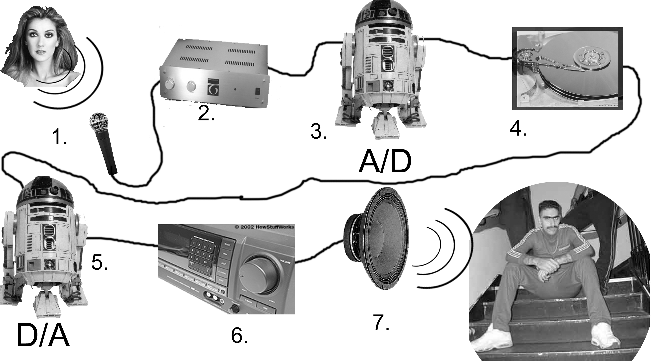
- Compression waves make a diaphragm vibrate. The vibrations cause voltage fluctuations.
- These fluctuations are amplified. (note: amplifiers before recording are called pre-amplifiers or pre-amps to avoid confusion.)
- These fluctuations are sampled by an Analog-to-Digital Converter
- The digital information is stored on a medium (DAT tape, Hard Drive).
- The sampled digital information is converted to voltage fluctuations by a Digital-to-Analog converter.
- The fluctuations are sent to an amplifier
- The amplified fluctuations cause a diaphragm to vibrate, creating compression waves that make us rock out.

As you see, we’ve added two steps. The sound must be sampled to become digital information, then the digital information must be converted back to voltage fluctuations. The A/D and D/A converters do this for us.

Sampling:

How does an analog waveform become binary you ask? Ok, you probably weren’t going to ask, but here goes:

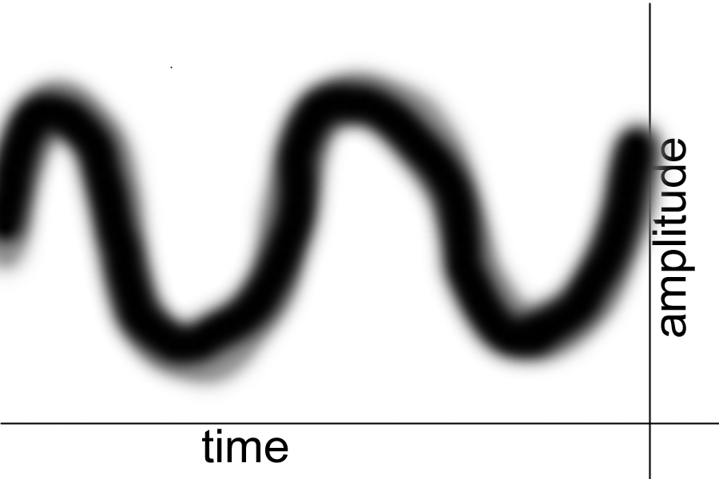

Imagine that this is an analog wave form. The peaks and troughs represent the change in amplitude picked up by the microphone.
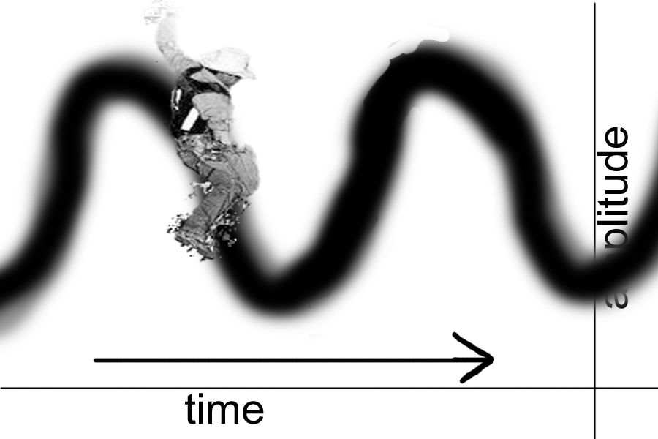
Now let’s imagine the wave moving forward in time.

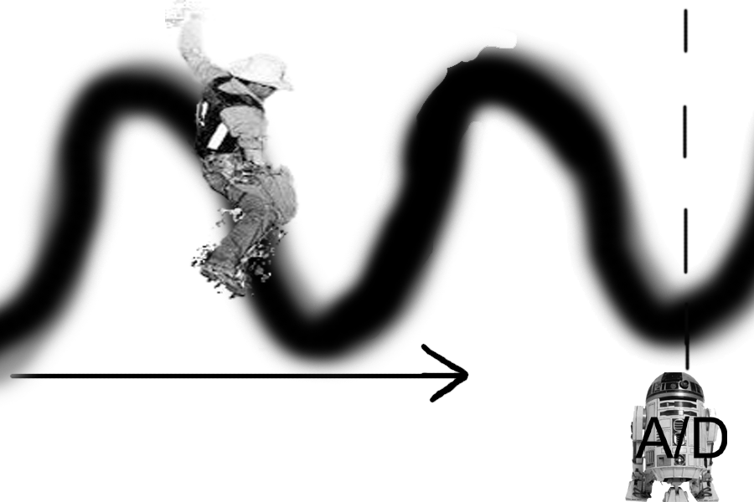
Now let’s add an A/D converter. The A/D converter will sample the waveform moving past it. The converter records an amplitude value and a time value. For the sake of simplicity, let’s say that the A/D converter has a 2 bit bit depth. This will allow it to record (2*2=4) 4 different values for amplitude. (a 16 bit A/D converter would be able to record (2*2*2*2*2*2*2*2*2*2*2*2*2*2*2*2=65,536
different amplitude values.

Let’s look at an example of what our 2 bit A/D converter will spit out:

Time=1 Amplitude= 1
Time=2 Amplitude= 2
Time=3 Amplitude= 4

This creates a nifty little, easily digestible digital approximation of the waveform. Visually, it would look something like this

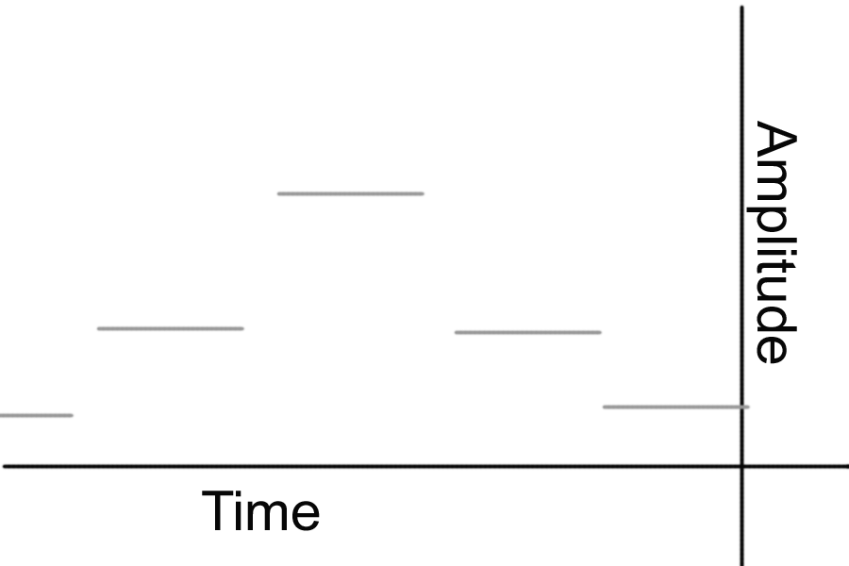

As you can see, we’ve lost a lot of information after sampling. One way that digital audio tries to get around this is through a process called anti-aliasing.

Anti-aliasing attempts to smooth abrupt changes in a digital waveform. Those of you with graphics experience will remember that visual anti-aliasing blurs the edges of a pixilated image to give it the appearance of smoothness. Same principle here.

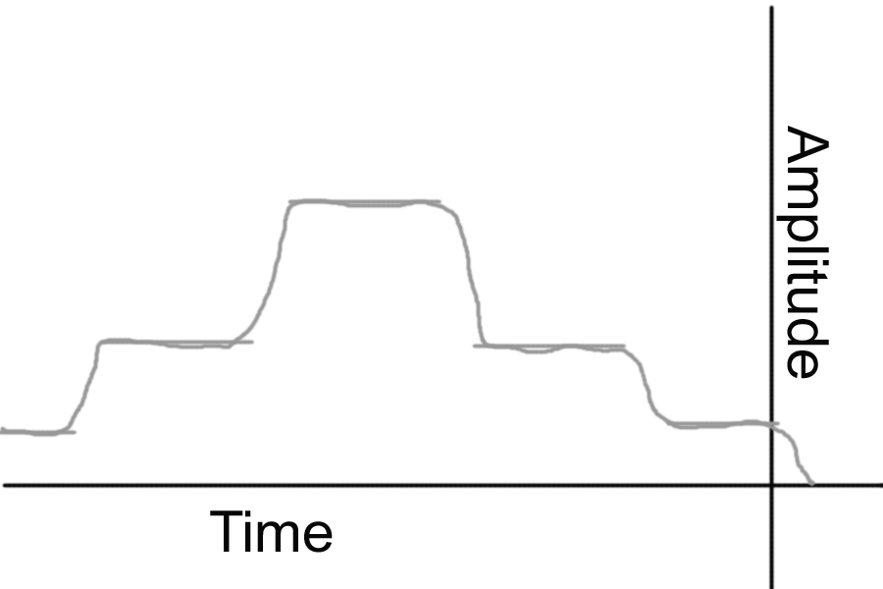

Why is this important:

Because digital audio is anti-aliased in the A/D process, you will want to keep your recordings in the digital domain as long as possible after they have been sampled. Multiple passes of A/D and D/A conversion will degrade the sound quality and cause your waveform to lose information.
As an example, let’s say that you are using a DAT recorder. A DAT converts analog audio to digital information immediately before the audio is recorded to tape. An A/D converter samples the incoming audio signal and writes that information to the tape. If you then plug the analog outputs of the DAT into Pro-Tools’ analog inputs, you will be converting the digital information back into an analog audio signal, then the Pro Tools hardware will sample that truncated audio signal, going through another round of A/D conversion. The solution is to use the digital output on your DAT recorder.

Sampling Rates and Bit Depths.

The sampling rate you record it is basically how frequently the A/D converter will take a sample of the audio information. Sampling frequency is measured in kHz. CD’s have a sampling rate of 44.1 kHz. DATs will record at up to 48 kHz.

These sampling frequencies are related to something called the Nyquist ratio. This Nyquist guy figured out that a certain frequency range can be captured at twice the sampling rate. The 44.1 kHz sampling rate of a compact disc corresponds to the roughly 20 Hz- 20 kHz range of human hearing.
For more information, see Jenn. I tend to just think of the Nyquist ratio as magic.

The higher the sampling rate, the more accurately a waveform will be represented in time.

Bit Depth measures how many levels of amplitude an A/D converter will store. Remembering our earlier example, a 2 bit A/D converter will give us 4 different values for the amplitude of a waveform. A 16 bit A/D converter will give us 65 thousand possible values for a waveform’s amplitude.

The higher the bit depth, the more accurately a waveform will be represented in amplitude.

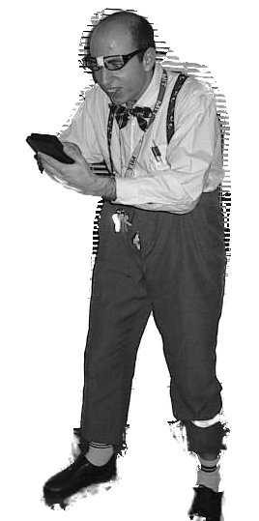
As painful as that may have seemed, it will give us a framework for talking about digital audio and Pro Tools. Now on to the Fun Stuff!

And now a quick rant to fill up space:

Microphone Placement is King!

It’s easy for us to be led astray by all of the options we have with digital audio. Such cool toys, no? It becomes increasingly easy to forget what I believe is the most important aspect of any recording: microphone placement.

Take some time before you record to try different mic’ing strategies: Try mic’ing closely with low gain, far away with more gain, above and below your subject. Experiment with angle.

Listen to old recordings for inspiration. Before all of these gadgets and gizmos, there were masters of mic placement.

Try spending twice as long as you think you need to mic your subject. It’s something I’ve been trying to do lately (as long as no one is paying for studio time) and it’s been a valuable teacher.

Ok, I’m done.

Pro Tools!

Pro Tools is a multi-track audio recording and editing program. It is far sexier than that previous sentence sounded. Pro Tools basically gives you an entire recording/mixing studio in a box.

My favorite aspect of digital audio is that it can represent audio visually over time, which is quite a heady concept. Without further ado, let’s see what this beast looks like:

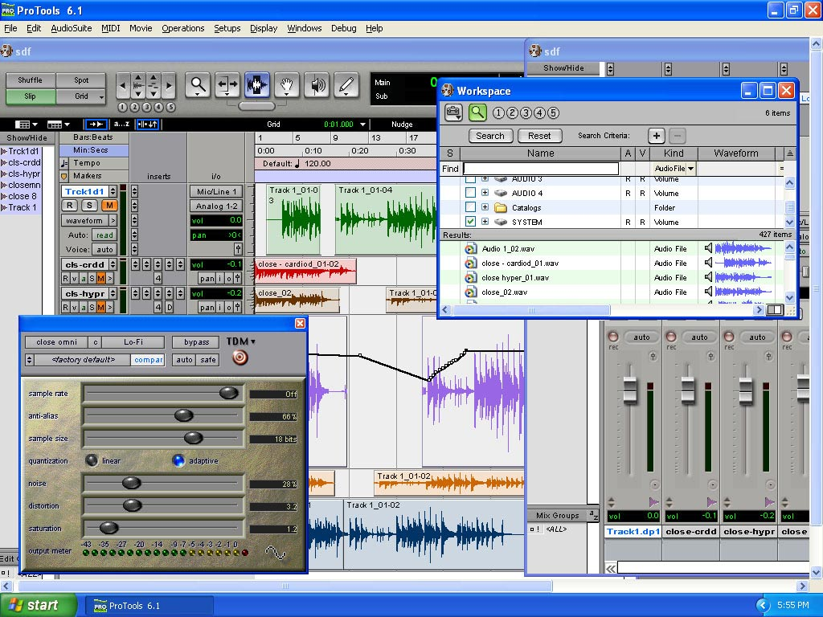

The Edit Window

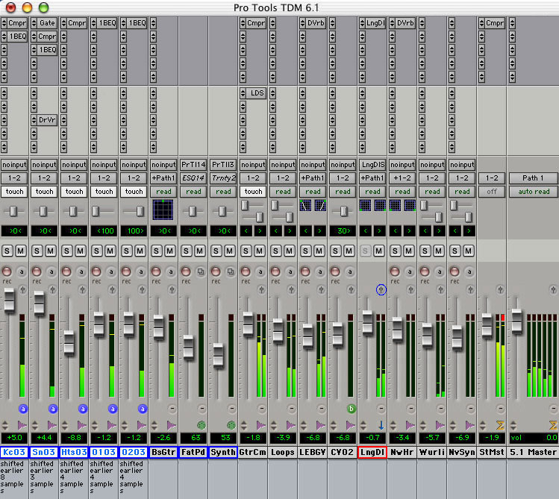

The Mix Window

Pro Tools is broken into two main sections: the Edit window and the Mix window.

The Edit window will look vaguely familiar to anyone who has used a nonlinear video editing program before. Multiple tracks of audio are shown together. Time is represented going left to right, and each track shows its own amplitude waveform. The edit window is used to manipulate and arrange the content of your audio tracks in time.

The Mix window will be familiar to anyone who has used a mixing console before. Each discrete audio track has volume and pan faders, as well as spots to put effects. The mix window is used to adjust how your tracks sound.

Speaking of tracks… what the hell is a track?

- "Track" - The Pro Tools Session windows are arranged somewhat like a visual representation of a multi-track tape recorder, with virtual "tracks" arranged from top to bottom. The sound regions in the tracks can be displayed as waveforms, color coded for convenience. Like this:
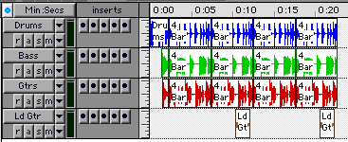

Here are some other definitions we will need to know:
- "Session" - Pro Tools creates documents called "sessions" for each new project, or for alternate versions of a project. These are basically just a set of instructions as to what sounds or portions of sounds you want to play and how you want to play them. The actual sounds are accessed in a non-linear fashion from hard drives, so this is all a non-destructive editing and mixing process.
- "Session Folder" - Pro Tools creates these folders in which to store session documents, and also creates two Sub-folders as needed -- one for Audiofiles and one for Fade Files.
- "Audiofiles" or "soundfiles" (sometimes referred to as "disk files.") - These are the actual digital sound recordings that reside on the hard drives. Each file should have a unique name so that Pro Tools can't get "confused" about which file it's supposed to play.
- "Fade files" - When Pro Tools makes an editorial "fade in" or "fade out", it creates a small separate audio file of the sound being faded in or out. In other words, creating a three second fade out would make a little three second audio file that Pro Tools would access as needed. These are stored in the "Fade Files" sub-folder inside the Session Folder. [An alternate method of doing fades requires automating mix settings, where you write instructions to raise or lower the volume as needed.]
- "Regions" - A Region is just a portion of an audiofile. (A region can actually consist of the entire soundfile, but in practice this usually isn't the case.) Just to illustrate, here's a guitar riff audiofile called "Ld Gtr"--

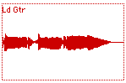 | <----Here's the complete soundfile/region as Pro Tools would display the waveform.  Here's the same sound after being edited into two separate Regions (note how Pro Tools has slapped the ID numbers "03" and "04" on them to keep them distinct. ------> | 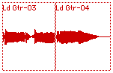

Great, now we can speak Pro-Tools-ese.

The Edit Window:

This is what the edit window looks like….oh god.
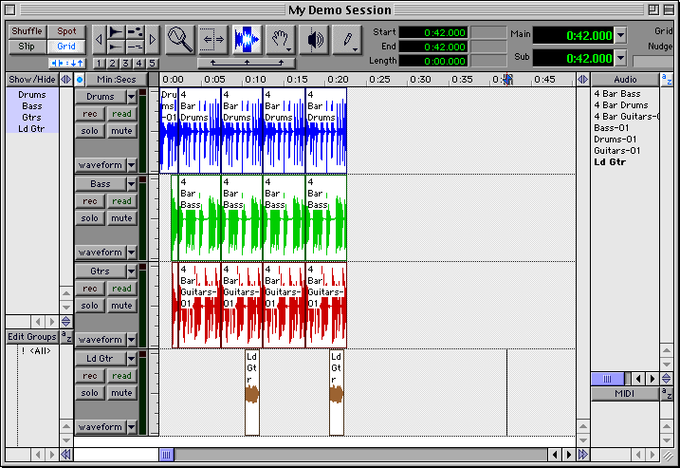
In a nutshell:

The center of the screen represents the different audio tracks that you have in your session.

To the left of the track view are two windows: Show/Hide and Edit Groups.

Show Hide allows you to choose which audio tracks will be visible on screen. All highlighted tracks are visible. If a track is clicked on, it will be hidden. It will still play, but cannot be seen or edited. This can be used to relieve clutter and “protect” tracks from editing. (It’s a great idea to hide valuable tracks when a band member who’s had a bit too much decides that they want to play with the computer).

Edit Groups are far more useful. This window allows you to define and select different groups of tracks to be edited at the same time. Let’s say that you’ve recorded a drum kit across four different tracks (kick, snare, and two tom/overhead mics). By making a group for the drums tracks, you can select and edit the 4 drum tracks together, basically treating them like they were one track temporarily. Intelligent use of edit groups can really speed up your workflow with complicated projects.

To your right are the Audio regions and MIDI regions windows. These serve as storage bins for the audio and midi files used in your project. When you import audio to Pro Tools, it will appear in the Audio regions window. We’ll talk about MIDI later.

The Audio regions window allows you to select, modify, delete, etc the constituient elements of your project. For the nonlinear editor kids, it is used just like bins in Avid or Final Cut.

Location Displays
The location displays at the top right of the screen are pretty easily ignored. After all, they’re just a bunch of flashing green numbers, and we’re getting film degrees because we decided we hated numbers.
As you become more comfortable with Pro Tools, the Location displays will become great friends to you. It’s ok to ignore them while working for now, let’s just talk briefly about what they do:
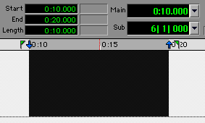 | The Start and End positions of the selection are indicated, as well as its Length.  In the "Main" window just to the right, the current position from which Pro Tools would start playback is given. (Most of the time you'll have Pro Tools set up to play from the start of a edit selection, so this "Main" window is usually the same as the "Start" window.) The "Sub" display is just a way to get the same Main Position, but in different units -- which is probably a lot more information than most people want.

Toolbar Buttons:
At the top left corner of Pro Tools are the Toolbar Buttons. This is where “you live” in Pro Tools. All of your interaction with the audio tracks visible below will be done with these tools and modes.
Hear This!:
Because you will be constantly moving between these tools and edit modes, learn the keyboard shortcuts now! This will save years from your life, and make working with the program so much more like playing an instrument and less like typing a paper.

Use the ~ (tilde) key at the top ledt of the keyboard to toggle through edit modes.
Use the F5 – F10 keys at the top of the keyboard to move between the tools.
When I work with Pro Tools, I have one hand constantly hovering over these shortcut keys.
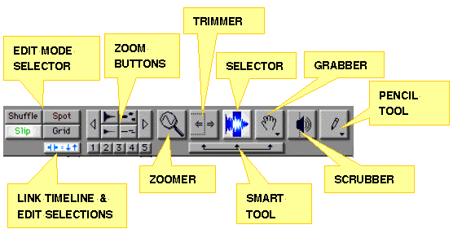
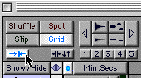 | This is the "Tab to Transients" button. It’s a great key that will cause the tab key to move forward to the next peak in your waveform. It’s pretty advanced, but ya might as well know
But first we'll start with the basics. Let's skip the Edit Mode Selectors on the far left for a moment and look at the "Zoom Buttons."
Zoom Buttons | 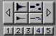
Clicking on the arrow pointing right will change the waveform display so that it "stretches" horizontally, showing a smaller portion in more detail. Click again and it expands again.
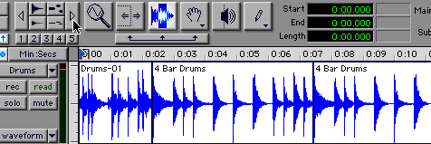
Now try clicking on the arrow pointing left; it does just the opposite, letting you see more of the waveform over time, but in less detail. Now try playing around with the upper and lower buttons next to the Left Arrow; you'll see that the vertical display is affected, showing greater or less detail of the height of the waveform.
[More "Zoom" trivia: The buttons just to the right of the waveform height buttons control the display of MIDI notes, which we won't cover. And the buttons numbered 1 through 5 store pre-sets of Zoom Display Settings. You can experiment with the defaults; or if you come up with a favorite Zoom setting you can store it to a button by COMMAND-CLICKING the button.
Like most of these tools, the Display Scale Arrows also have some "combination keystroke" options to expand its uses. For instance, you can easily toggle back and forth between a zoomed-in view and previous level of viewing by holding down the Option key while clicking any of the Display Scale Selector Arrows. (This will have more relevance when we look at other methods of zooming in on the display.]
Before moving to the next editing tool, click the right Display Scale arrow a couple more times so that we're "zoomed in" with more horizontal detail than we started with. Now we're ready to try out the basic Editing Tools which are the Zoomer, Scrubber, Trimmer, Selector, Grabber, and Smart Tool.
The Editing Tools | 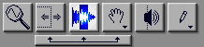
Here's where you need to spend some time just fiddling around and getting a feel for the tools.
The editing tool icons are arranged as Buttons on the Toolbar. Clicking on the buttons turns the mouse pointer into the appropriate tool when you move the pointer into the waveform display.
- The Zoomer icon resembles a magnifying glass; it's used to quickly zoom in and out on the waveform display to show more or less detail as needed.
- The Trimmer -- to the right of the Zoomer -- is normally used to snip off unwanted sound at the beginning or end of a particular audio region. Or it can do the reverse and extend sound that was previously trimmed.
- The Selector icon resembles a waveform with a dark bar highlighted the middle; the selector is used to highlight audio regions or portions of regions for subsequent actions. The position of the selector bar can also determine the point at which playback of sound begins.
- The Grabber looks like a hand; it's used to "grab" onto entire regions and move them around to different places within a session.
- The Scrubber icon looks like a loudspeaker; we move the Scrubber back and forth across a waveform to audition a portion of sound at slower than normal speed. This is often needed to do to locate some subtle detail in a track.
- The "Pencil Tool" is to the right of the Scrubber. We'll find interesting uses for the Pencil later on when we look at automating volume and pan information displays. However, please do not use the Pencil Tool on a region that is displayed in a waveform view. When zoomed into extreme magnifications on a waveform, the Pencil Tool is a destructive editing tool that actually modifies the waveform of the sound.This feature is seldom used and won't be covered at the intro level.
- The Smart Tool is relatively new to the latest versions of Pro Tools. It provides an easy way to switch between four common tasks: selecting, trimming, creating fades, and grabbing. I personally hate the smart tool, because I am used to using the hotkeys.
Zoomer | 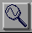
To start with, try double-clicking on the Zoomer. This should "zoom out to a wide shot" so that we are looking at the entire session. When the Zoom tool is highlighted and active, our mouse pointer becomes a little magnifying icon when we move it around the waveform display. Now try clicking on one of the waveforms and dragging the magnifier icon -- you notice a rectangular grid is selected. When you release the mouse button, the display should "zoom in" on the piece of audio that you just selected. You can repeat this process several times to continue examining the waveform in more detail. At some point the level of magnification becomes impractical for general purpose editing, so then just double click on the Zoomer icon in the toolbar to get the broad overview of the session again.
Or you can easily toggle back to the previous magnification by OPTION-CLICKING while in the Zoomer mode. (The "+" indicator on the tool icon will turn into a "-" when you hold down the OPTION key.

Trimmer | 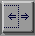
It's hard to describe the Trimmer action in words; you really need to play around with it. First, select it by clicking on the Trimmer button, now move your pointer to the last region of the top track.. Without clicking the pointer, which now looks like the Trimmer icon, place it about in the center of that region block and move it slightly right, then slightly left. You should notice that the Trimmer icon changes shape when it crosses the mid-point of the region. When it is closer to the end of the region, its shape changes so that it will trim off the tail of the region; when it's closer to the beginning, it will trim off the head of the sound.
Remember, this is all non-destuctive editing, so don't worry about making any mistakes here. Just position the trimmer so that it is to the right of the mid-point of the region. Now you can trim the region to that point just by clicking. You'll see that the region length has changed.
Now move the Trimmer slightly to the left, click, and trim off a bit more sound from the tail of the region. Next, position the Trimmer so that it is inside the region. Click and continue holding down the mouse while you drag the Trimmer to the right. This should extend the region, restoring the portions you previously deleted. Now experiment with trimming and restoring the beginning of the region.

Selector | 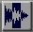
Turn your pointer into a Selector Tool by clicking on the Selector button. Now move the Selector/pointer into one of the regions and click on it. Nothing much happens except that a blinking selector bar appears at that point. But now try clicking and dragging the Selector, then releasing the button. You've now "selected" a highlighted portion of the region. You now have various choices as to what you can do with that portion. (One method of viewing some of the choices is to now pull down the Edit Menu from the Menubar. Notice that some of these are standard Mac items such as Cut, Copy, Paste,etc., with some standard keystrokes that apply.)
- Undo. There are 16 levels of Undo/Redo in Pro Tools. (The shortcut for Undo is command-Z.)
- Cut. This removes the selected portion (and simultaneously stores a copy of that portion in the clipboard, so that it can be pasted elsewhere if desired.) (command+X)
- Copy. Stores the selection in the clipboard. (command+c)
- Paste. This places the contents of the clipboard wherever you've positioned the selector cursor. (command+v)
- Clear. This deletes the selection without storing it to the clipboard. (Note: You can use the keyboard Delete key to do the same thing. I find this to be easier than pressing COMMAND-X or COMMAND-B.)
- Duplicate. This tacks a copy of the selection onto the tail end of that selection. (command+D)
- Repeat. Just like "Duplicate", except a dialog comes up asking you how many times to repeat the region. (Handy if you like to create incredibly repetitious rhythm tracks.)
- Capture Region. When you choose this action, you're prompted to enter a name for the region. This selected region then appears in the Audio Regions List under the name you've given. From there it can be dragged into the session when needed. (Useful for identifying "good bits" that you might want to use elsewhere, such as a "Cymbal Hit" or "Big Car Crash".)
- Separate Region. Choosing this creates region boundary lines, so if you had one big region and separated a piece in the middle, you now have three regions. By fiddling with preferences, you have the option of either naming this new region or having Pro Tools slap an I.D. number on it. (Why bother separating regions? In order to treat a portion of a track differently from the adjacent sound, we need to "define" it as a separate region. (command+E)
- Trim Region. This not only separates the selection from the larger region from which it came, it deletes the regions on either side. (As in, "I want this Cymbal Hit but I don't want the stuff that comes before and after.")
- Heal Separation. Basically "undoes" a separation, provided that you haven't nudged the regions around on the timeline.
- Mute/Unmute. Suppose you had separated a region -- like that Cymbal Hit -- because you didn't like it. This would allow you to Mute just that part of a track, where the Cymbal Hit occurs, without affecting the rest. (Later, we'll also see that you could also simply adjust the level of that separate region.)
- Lock/Unlock. When you get a region placed just where you want it, this allows you to "lock" it in place on the timeline so that it can't get accidentally moved. (Little "padlock" icons appear on the region.)
There are still more choices in that Edit Menu, but that's plenty for now. Especially since there are two important "combo strokes" to know about when using the selector:
- Holding down the Control key when the Selector is in a waveform allows you to scrub audio using the selector. (Saves the trouble of having to click on the Scrubber button, then going back to the Selector button.)
- Double-clicking with the Selector highlights the entire region. (this can be handy.)

Grabber | 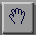
That hand icon seems pretty straightforward; you grab onto regions and move them around. Try it out on one of those "4 Bar Bass" regions. Easy, huh?
But the grabber has other uses and variations on its basic use. Try double-clicking with the grabber on that same region. You should get a dialog like this:
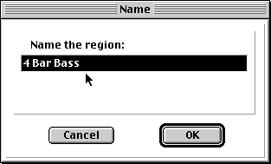
Go ahead and rename it if you like. Try "Bass Riff." You'll notice that the other duplicates of that region also get renamed, and that the new region name appears in the list window to the right. Naming regions is often very useful. You can call them anything you like, because it doesn't affect the original audiofiles. But pay special attention to the next scenario.
If you were to double-click with the grabber on the region called "Ld Gtr" you would get a different prompt, like the following:
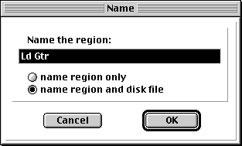
You'll notice that this dialog defaults to the choice "name region and disk file." It did so because in this case, "Ld Gtr" is not just a piece of some larger audiofile -- it's the entire audiofile. This is a critical distinction: DO NOT ACCIDENTALLY RENAME DISK FILES -- those are the original audiofiles. Any sessions other than the current one depend on those original file names.
Re-naming audiofiles this way can create a dilemma, particularly if you have multiple versions of a project referencing the same audio files. The safest way to go is to rename audiofiles before you begin editing.
[Here are some advanced combo strokes involving the Grabber --
- "Option-Grab" -- if you hold down the Option key while you grab and move a region, you create and move a copy of the region, leaving the original alone.
- "Grab-Control" -- first, move one of those regions off to the right somewhere so that there's no other region in the track just below it. The region you moved should still be highlighted; click the Grabber in an empty part of a track -- this will deselect the region you moved. Now we can demonstrate this move, because the sequence is important. Re-select that region by single clicking on it with the Grabber. Now press the Control key and hold it down while you try to slide the region to the track below it. You should find that while you can move the region to any track, it will maintain its position on the timeline. In other words, you can move it vertically but not horizontally. (Very useful when you have sound effects in sync with picture, but you want to move them to a different track.)
- "Control-Grab" -- Highlight a region. Now press Control and grab some region in a different track -- and the second region will snap to a new position so that left edges of the regions line up. Handy when you want sounds to begin simultaneously. A variation on this technique: place the selector anywhere you want, then switch to the Grabber. When you Control-Grab a region, it will snap to the time position where the selector was.
- "Separation Grabber"-- if you click and hold down on the Grabber button, a "pull down" of two different Grabber modes is revealed. The "Time" choice is the default; you grab and move regions around on the timeline or from track to track. But if you select the "Separation" mode, the Grabber will work like this: if you grab any portion of a region previously highlighted by the Selector, the Grabber automatically "snips" that piece and separates it from the rest of the region so that it can be moved elsewhere. It's just a convenience, combining a couple steps into one move.]
Scrubber | 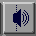
Now click on the Scrubber button and move your mouse pointer onto one of the waveforms. The pointer should turn into a speaker icon. Now click and hold the mouse button while you move the mouse, "dragging" the speaker icon back and forth slowly across the waveform. You should hear the sound playing, corresponding to your mouse movements. (This is the digital equivalent of the "scrubbing" technique done for many years by moving analog tape back and forth over a playback head.) Release the mouse button and try the process again on a different waveform or portion of the same. Slow, subtle mouse moves should produce slow, subtle scrubs.
Note: Earlier we looked at a more convenient way to access scrubbing by pressing the Option button while using the Selector tool.
The Pencil Tool |  |  | 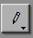
 | We'll come back to the Pencil Tool in detail when we look at volume and pan automation. Briefly, the Pencil Tool can be used to "draw" a line representing changes in volume or stereo panning. But as mentioned above, when a region is viewed as a magnified waveform, the Pencil Tool can also be used as a destructive editing tool that can "redraw" small portions of waveforms, altering the original soundfiles forever | 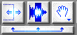
The Smart Tool is represented by a bar beneath the Trimmer, Selector, and Grabber icons. The Smart Tool combines several functions, switching between them by "sensing" what you want to do depending on where the Tool is positioned within a region.
- Position the Tool in the upper half of a region, but not too close to the start or end of the region, and it becomes a Selector.
- Position the Tool in the bottom half of the region, about in the middle of the region, and it becomes a Grabber.
- Position the Tool near the beginning or end of a region and it becomes a Trimmer.
- Position the Tool near the beginning or end of a region and move it vertically so that it's near the top of a region and it becomes a "Fade In" or "Fade Out" tool. You'll have to experiment with dragging this tool to vary the length of these fades; it takes a little getting used to. You can also do crossfades between two adjacent regions by moving the Tool to the border between them, and positioning it toward the bottom part of the regions. (More on fades & crossfades later.)

The Edit Mode Selector | 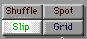
The four different Edit Modes affect the operations of cutting, deleting, pasting, and duplicating and also affects actions performed with the grabber. You should experiment to get a feel for how the different modes operate.
- Shuffle mode - In the shuffle mode, when you perform an action, the regions will tend to "snap together" end to end. For instance, any time you use the Grabber to highlight and move a region, that region will tend to snap up against the end of whatever region preceeds it on the same track. (Other non-highlighted regions further to the right of the moved region will remain stationary when you do these Grabber moves.) However, things get trickier if you do a cut or deletion. If you select the mid-portion of a region and cut or delete that selection, the region to the right of the deletion will move to join up against the end of the remaining region. Also, any regions to the right of the deletion will "jump forward" along the timeline by the same amount. Look at this "before & after" deletion done in the Shuffle mode:
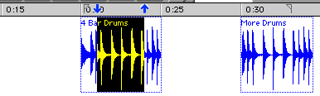 | <-----The highlighted portion is selected for deletion.
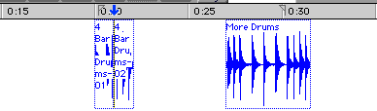 | <-----After the deletion. The remaining piece of "4 Bar Drums" has snapped to the left to join the up against the first piece. Also notice how the "More Drums" region has moved along the timeline, by the same amount as the length of the deletion.
This is why you need to be careful if you use the Shuffle mode when editing sound to picture, as you can inadvertently change the sync relationships of sound regions and picture.
- Slip mode - In this mode, regions can be slipped around freely with the Grabber, and if a deletion is made within a region the two remaining pieces remain in their original places along the timeline. Also, a region can be placed so that it "overlaps" another. (This doesn't mean that Pro Tools will play both overlapping sounds at once; the new overlapping region "hides" the underlying region. Pro Tools will simply switch from playing one sound to playing another, as if the two sounds were spliced together.)
Here's the same deletion as above, done in the "Slip" mode.
 | <-----The same highlighted portion is selected for deletion.
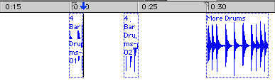 | <-----This time all the remaining regions maintain their position on the timeline.
- Grid mode - Grid mode acts much like the Slip mode, except that the movements of the regions are constrained to user-selected increments. These increments are `chosen via the Nudge/Grid Selector, which is at the upper left. Clicking on the unit displayed will reveal a pop-up menu. Like this:
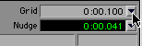 | <------ Clicking on the button brings up a pull down menu of unit choices, as seen to the right. | 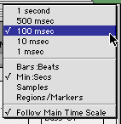 | <-------- In this case units of Minutes/Seconds are used, and an increment of 100 msec is selected. (That's 1/10th of a second.)
So if you were in working in the grid mode with units of "1 second" as your increment, a region could not be shifted by a fraction of a second; it could only be placed on lines determined by full seconds.
- Spot mode - The Spot mode is most useful for those who are syncing regions to a videotape that is striped with timecode and contains a visible timecode window burn. When you "Grab" a region in the Spot mode, a dialog window appears, prompting you to type in a time location where you want the region placed. This location can be in entered in different units (feet/frames, mins/secs, timecode numbers, or bars/beats) depending on how we set up our Time Scale.
While the Grid and Spot modes are essential for those working with film and videotape, the Slip and Shuffle modes are probably the most useful for those working on intro level projects.
[About that "Nudge" field: it has a similar pull down menu where increment units can be selected. Here's what "nudging" means -- when you have a region highlighted, you can use the "-" and "+" keys on the keyboard to move the sound earlier or later on the timeline, one increment unit at a time. Very handy in film work on the larger Pro Tools-24 systems, where increments of 35mm film frames and timecode values can be chosen. The Pro Tools LE systems don't have this option, a failing that is presently rather controversial in the pro audio world.]
The Time Ruler
The Time Ruler is the thin "ruler bar" that appears just above our audio track display. It gives us our orientation as to where regions occur during playback.

Mix Window Basics:
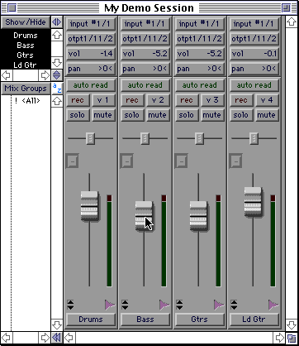 | The Mix Window gives us control over the playback levels of our tracks. By clicking and dragging on these virtual faders we can adjust levels. (When you do so, you'll notice that the numbers in the "vol" box will change accordingly.)  Experiment a bit with those levels now; you can use the Return and Spacebar keys to play the session, or use the Transport Window. (Note: If you click on the Edit Window, it becomes active and hides the Mix Window. But you can get the Mix Window back by pressing Splat-Equals Sign.)  Beside each fader is an individual level meter; as a rule none of these meters should indicate red (or digital clipping.) If you get a clipping indication, adjust the fader level downwards. Then click on the meter indicator that shows red; this will clear the red indicator from the display. Now play your sounds again, watching the level for signs of further clipping.  [Note: If you're moving the faders and the meter levels don't seem to be affected, an option called "Pre-fader metering" is probably turned on. You can toggle it off by pulling down the Operations Menu.]
Remember that despite what these Pro Tools meters indicate, if you're recording onto an analog deck it's the combined level into your target tape deck that is most important. Get all your level adjustments lined up in your analog audio chain first; then you can fine tune the mix in Pro Tools.
Just above the volume faders are some sliders that move from left to right; these are pan pots that will position the sound for a stereo effect. (The default position leaves them in the center, which will produce a mono mix.)
Note also the mute/solo switches which can help you isolate sounds as you experiment with levels.

