Usability Testing Research Project

Website/Software name: Ringlight.us, Ringlight

Designer/Company: Brandon Wiley

Brief Bio about the Developer- Ringlight is software venture by Brandon Wiley. Brandon Wiley is a software/product developer and hacker. He has experience with open source software development as well as closed sourced develop. His open source development consists of Freenet, ACTLab.tv, Snakebite and many other projects. His closed source developments include Onion Networks, swarmcast peer-to-peer network acceleration software and BitTorrent’s DNA, a peer to peer accelerated B2B internet solution.

Brief background about Ringlight- Ringlight was originally conceptualized in the spring of 2006 as a website/software that would allow users to directly access each others documents for download and streaming. The model is best described as a social networking space where documents are experience between each user so they can share creative works, as well as work collaboratively on projects.

The initial design was began by Brandon Wiley, he then enlisted the help of Aimy Steadman and Joseph Lopez to help develop the software, Aimy focused on the actual website design, Joseph Lopez does usability testing.

There are two main components to ringlight, the software and the website portal.

The software is a headless server that runs in the background. On windows you can see ringlight on the taskmanger, represented as a ring, you can right click on the ring and a menu pops up.

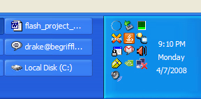

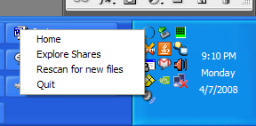

Your Ringlight folder-

This is where you store all the files you would like to be available on ringlight, you can also just put shortcuts to files as well.

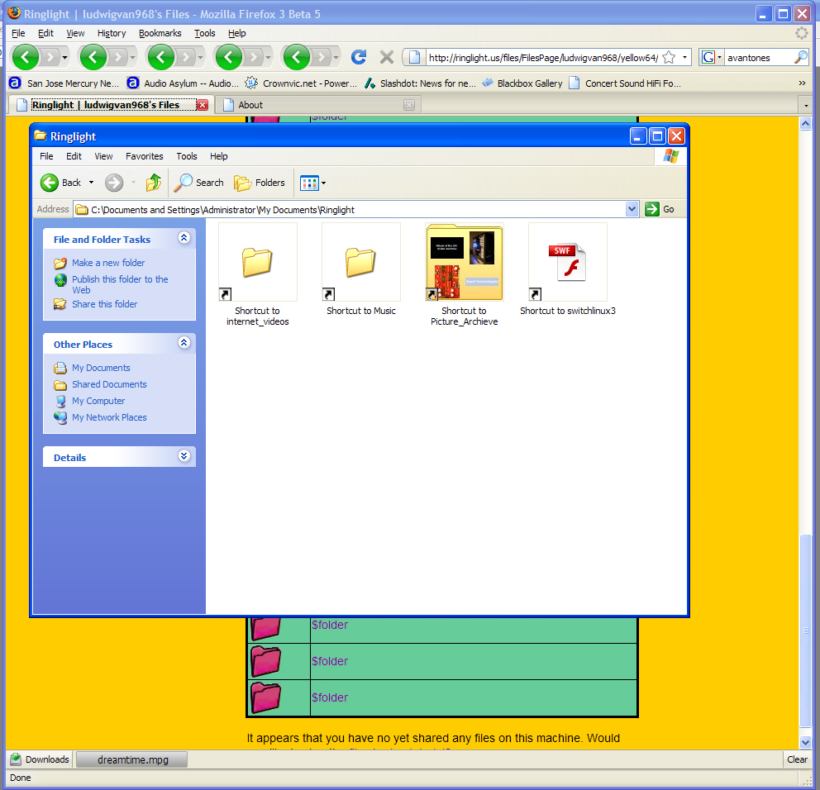

The Website-

The website is where all the interaction takes place. There are many features that have been developed and implemented since it’s inception. Here are the basic pages the users can access:

Welcome Page- This is the initial page that welcomes the user.

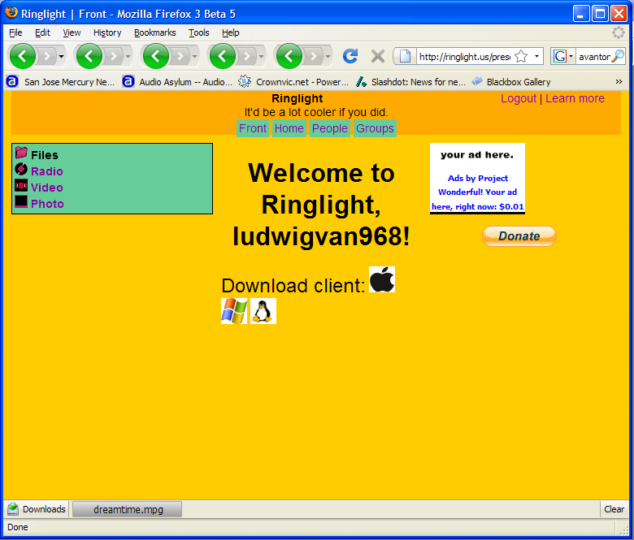

People Page- The people page lists the people online.

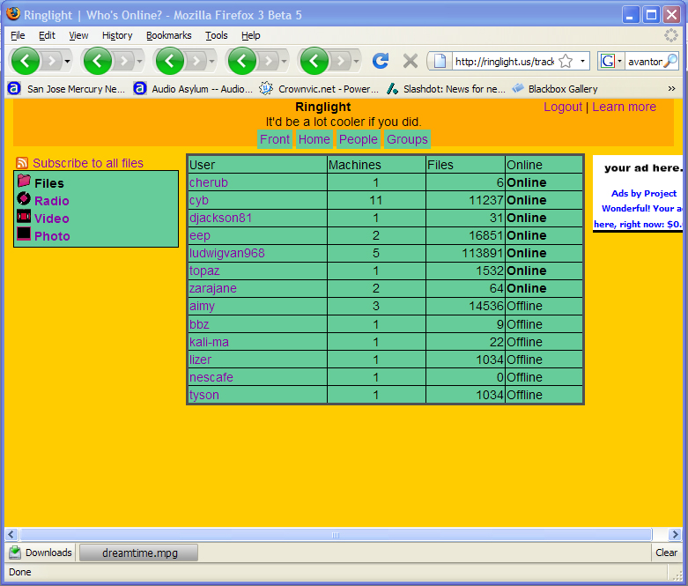

File Browser- The file browser page shows you what files are available and lets you download them, as well as choose from a side menu of streaming options.

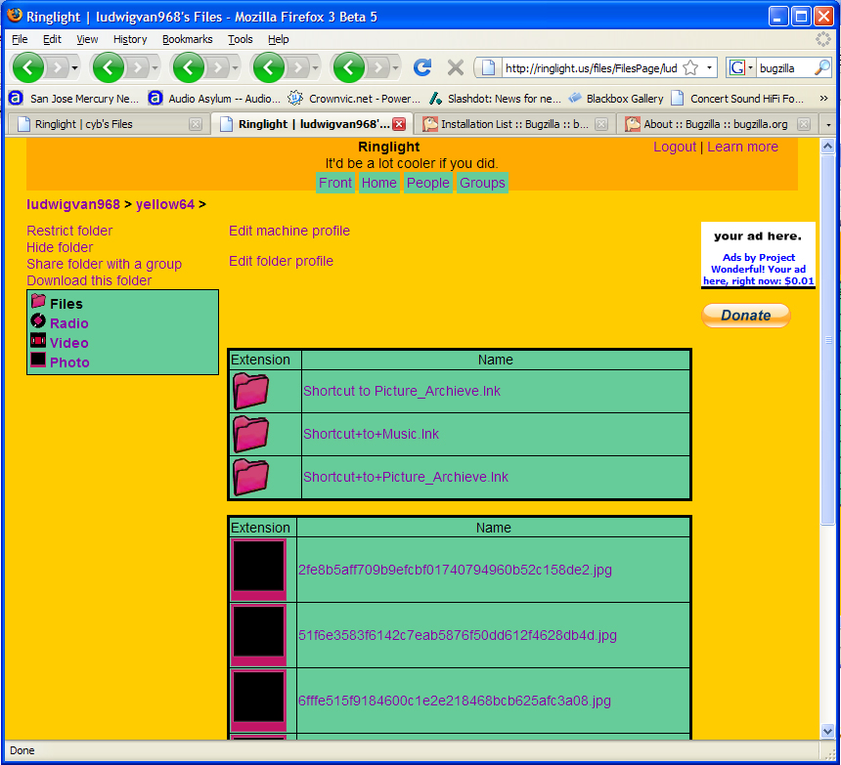

Video Page- The video page is a streaming interface:

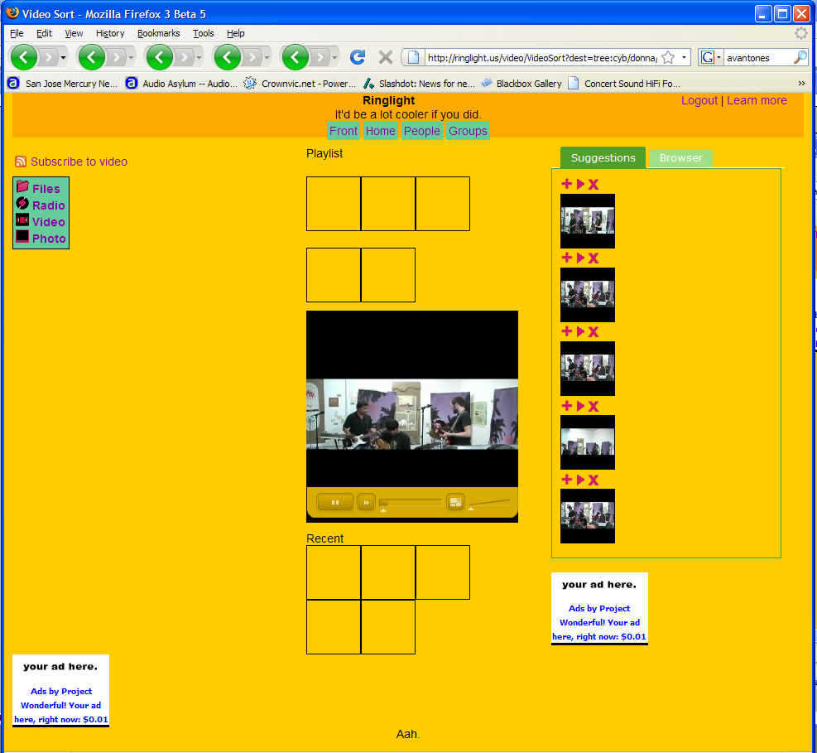

Photo Page- The photopage is a slideshow system:

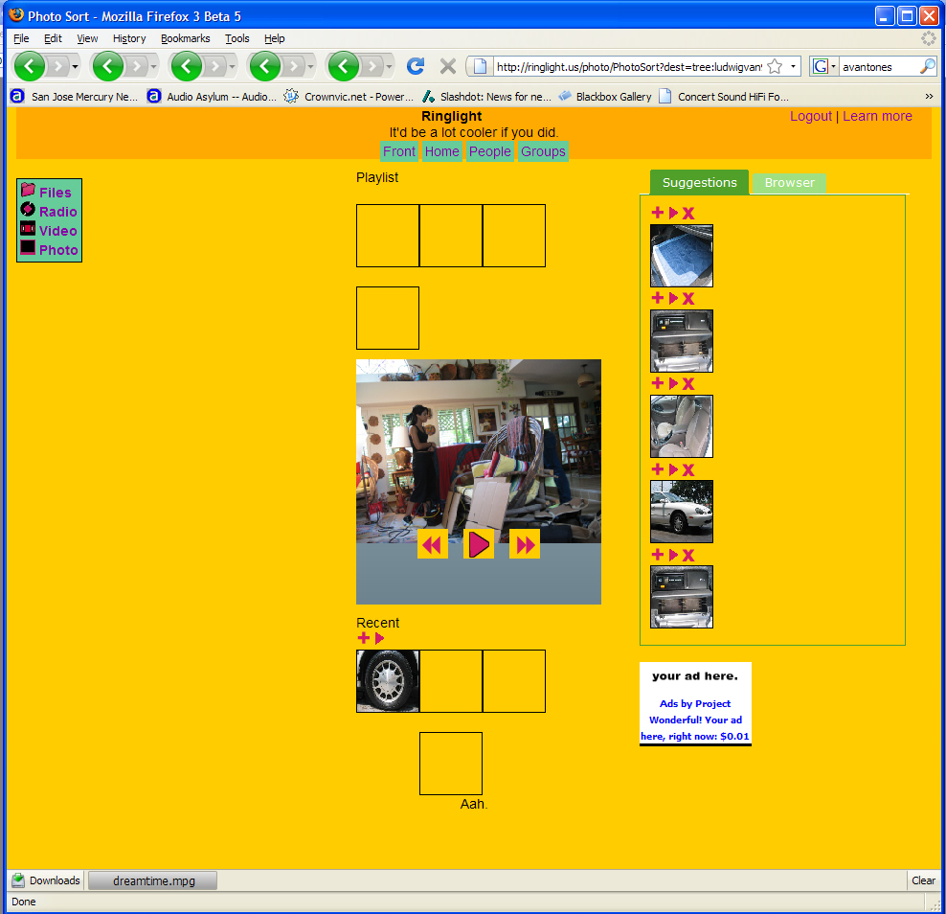

Radio Page- The radiopage allows you to stream music:

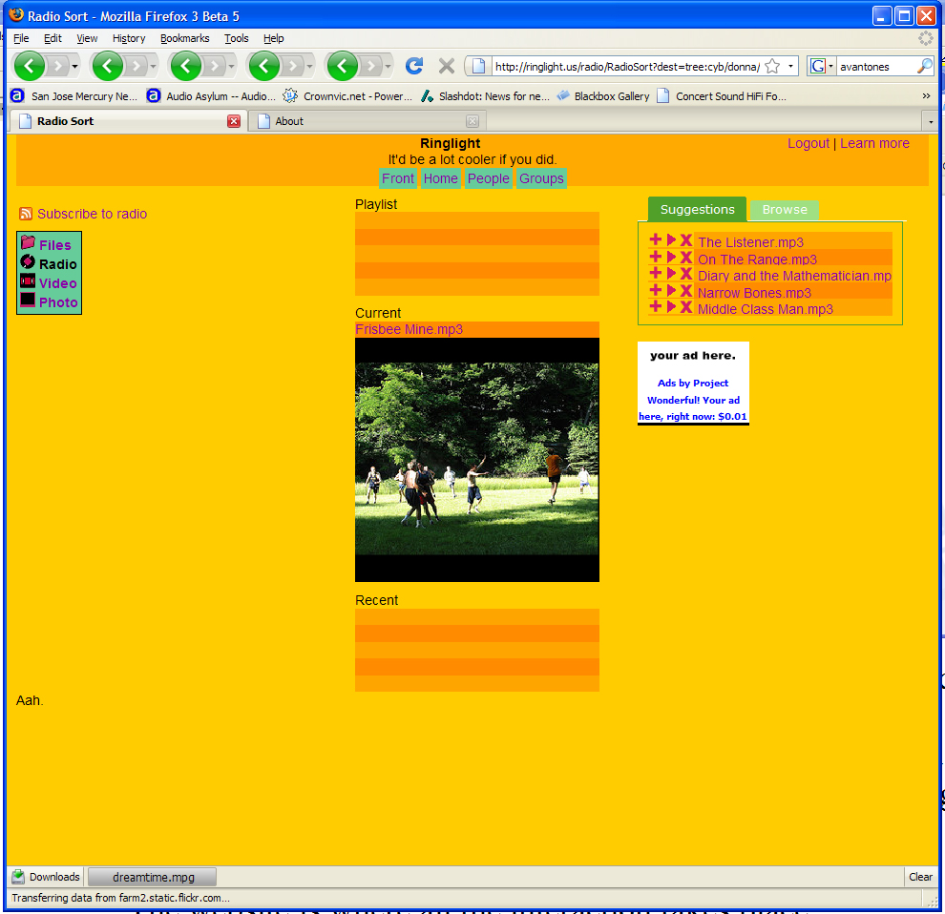

Learn More Page- The LMP page provides information about Ringlight and how it was developed.

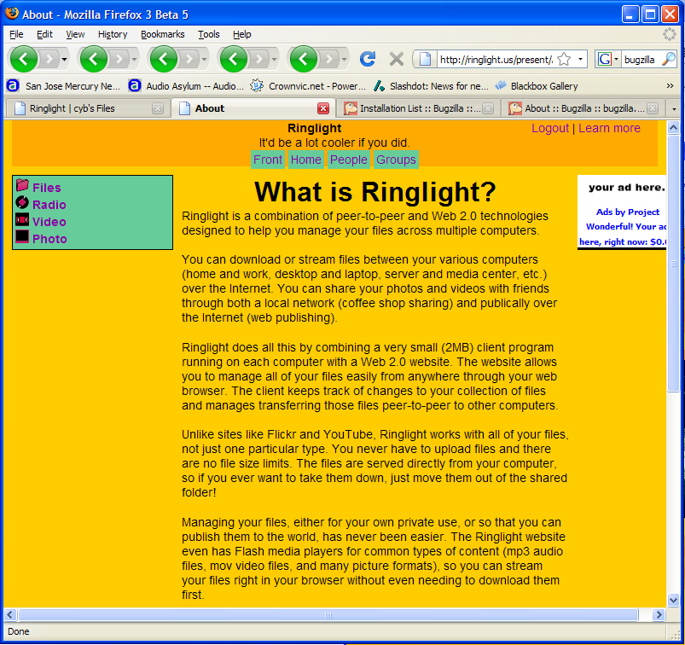

Help Page- The Help page provides information on how to use Ringlight.

RSS Feature- This feature is spread throughout the site, allowing you to join various feeds to keep you updated to user shares.

Usability Testing-

Since the inception of the Ringlight, the software/website has gone through many versions with the current version 1.17 released as a beta to testers. The software is multi-platform (Windows, Mac, Linux), so testing is performed on multiple systems. The most recent method of bug reports has been launched as a Facebook group, where users can post reports and Brandon can take the feedback and directly integrate change requests.

Previous to this method Joseph Lopez was the principle usability tester. With over 4 computers connected to the network, using all three platforms, Joseph would perform tests through enabling types of files for distribution, as well as test various features on the website for compatibility and streaming functionality. Joseph contributed over 120,000 files, mostly music, photo and videos from his personal archive.

The initial debugging stages mainly consisted of Brandon and Joseph meeting bi-weekly where they would discuss functionality and bugs. They would meet for 3-4 hours at a time, Joseph would test the site and file playback and Brandon would make changes on the fly to the code.

One example of debugging took place when I realized that Ringlight was using over 50% of my CPU when idle and it would constantly shut down. I would then show Brandon my issues, he would look at the logs and would try new solutions. On this occasion we figured out the reason Ringlight was using so much CPU cycles was because it re-indexing the files, however since I had over 120,000 files inserted in the system it would take a long time.

